Soil Erosion Activity

Subject: Erosion  Related Subjects: Soil Science | Grade Level(s):  Length of Lesson: | Type: Inquiry / Design / Project  Keywords: Soil Erosion, runoff, topsoil

Lesson Overview
Two containers will be filled with soil. One will have plain soil, and one will have soil with plant matter/roots. When water is poured through the containers, the water from the plant container will come out cleaner and demonstrate how soil erosion can be minimized with the planting of trees and other plants.

Lesson Focus
Students will construct a mechanism which holds both plain soil and soil with germinated plants in separate containers. The students will pour water into both containers, and analyze the clarity of the runoff, which will be stored in an attached container.

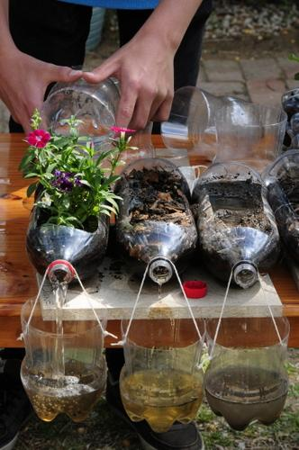

Lesson Objective(s) | The student will see how plant life and root structure affects soil erosion.

Lesson Timing

Time [min] | Description
5 | Introduce the Lesson  - End Goal  - Primer Questions  - Key Vocab Words
1 | Role Models in STEM
Engineering Method
5 | Real World Example
5 | Hypothesis & Prediction
5 | Brainstorm & Design
20 | Build & Create
10 | Test & Record
5 | Assess & Evaluate
5 | How to improve?
10 | Lesson Cleanup

Materials | - Sturdy boards (1 per group)  - Small plastic bottles, 2 per group  - Clear plastic cups (2 per group)  - Germinated sprouts  - Soil  - String  - Tape  - Glue  - Sharp object for cutting holes
Instructor Prep | - Step 1
Related Resources | - List related lessons/ppts etc available from USC or outside, trusted orgs

Lesson Plan

Introduction
- What forces can cause erosion?
  - Water
  - Wind
  - Living organisms
- How have humans caused erosion?
  - Farming
  - Deforestation
  - Construction
- How can erosion be minimized?
  - Planting trees
  - Crop/ animal rotation to allow for grass regrowth on farms
  - Stop deforestation without replanting

Procedure
- Distribute materials.
- In each plastic bottle, cut out a 3-4 inch strip from one side.
- Attach the other (closed) side of the bottle to a sturdy board.
- Fill one bottle with potting soil.
- Fill one bottle with grass sprouts (from terrarium lesson).
- Attach strings to both sides of a plastic cup.
- Fasten strings to the board so that the cup hangs below the mouth of the bottle.
- Pour water through both bottles.
- Analyze clarity.

Wrap-up
The purpose of the survey is to let us know your opinions about today’s project. Remember there are no right or wrong answers.

 |  | Strongly Disagree | Disagree | Undecided | Agree | Strongly Agree
1 | The project increased my interest in science
2 | After this project, I am more confident in doing science

3. What does a pedologist do?

4. What can be done to stop or limit soil erosion?

5. What are some effects of soil erosion?

Lesson Background for Teachers

Suggested Real-World STEM Connections

Real World Example
- When completing construction projects, contractors must consider how to minimize soil erosion and chemical runoff.

Hypothesis & Prediction
- How will the use of plants affect the clarity of the water when passing through soil?

Brainstorm & Design
- Students will simulate solutions to the real world problem of soil erosion.
- How could this solution be implemented on a larger scale?

Build & Create
- Students will build a mechanism which stores soil and allows them to see the clarity of water that has been passed through the soil.

Test & Record
- Students will test their design by running water through the mechanism and analyzing the result.
- Students will record qualitative data regarding the water clarity.

Assess & Evaluate
- Students will know if there design is successful by the functionality of their mechanism and the clarity of their results.

How to Improve?
- What other materials could be used to minimize erosion?
Role Model in STEM


Name: Guion”Guy” Bluford
Years: 1942-present
Quick Facts
- First African American in space
- Earned PhD in aerospace engineering
- Began career as a pilot in the US Air Force

Lesson Variations and Options
Include descriptions of alternative methods or ways to present things.

Explanation
The container with a root structure will produce clearer runoff because the roots hold the soil in place.

Key Concepts and Vocabulary
- Erosion
  - the wearing away of the land by forces such as water, wind, and ice.
- Topsoil
  - Top layer of soil, most fertile
- Runoff
  - Draining away of water
- Soil
  - Made of weathered rocks and humus
- Humus
  - Decomposed organic material

Safety Notes
- Safety instruction

